**AREA OF SHAPES ASSIGNMENT**

**Question**

**63afdaeb90354f85a8e37806fe7e8c09**

Write a program to calculate and display the area of a shape that the user defines via the keyboard.

1. The program should prompt the user to choose the shape, and then enter the required variables.

For example, if a user chooses a circle shape, then the program should prompt for the radius. Once the user enters the radius, the program calculates and displays the area.

2. The program should be implemented in any three programming languages of your choice.

3. Do the screenshots of the code and results and upload.

*Answers in 2 parts: Part A (If -else implementation); Part B (Switch-case implementation)*

*Answers start from the next page*

1. **Implementation Using If-Else**
2. **Implementation using Python**

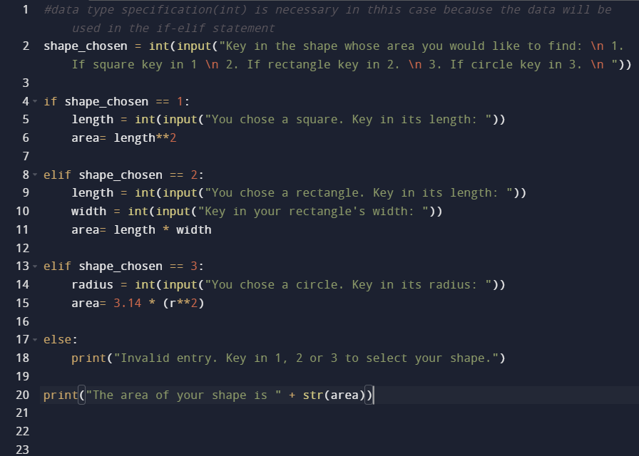

**Result:**

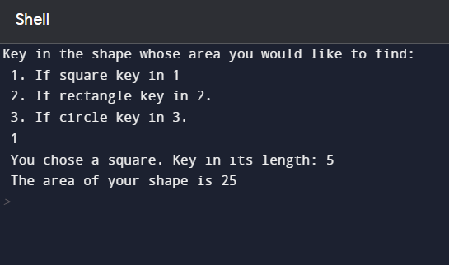

1. **Implementation Using C++**

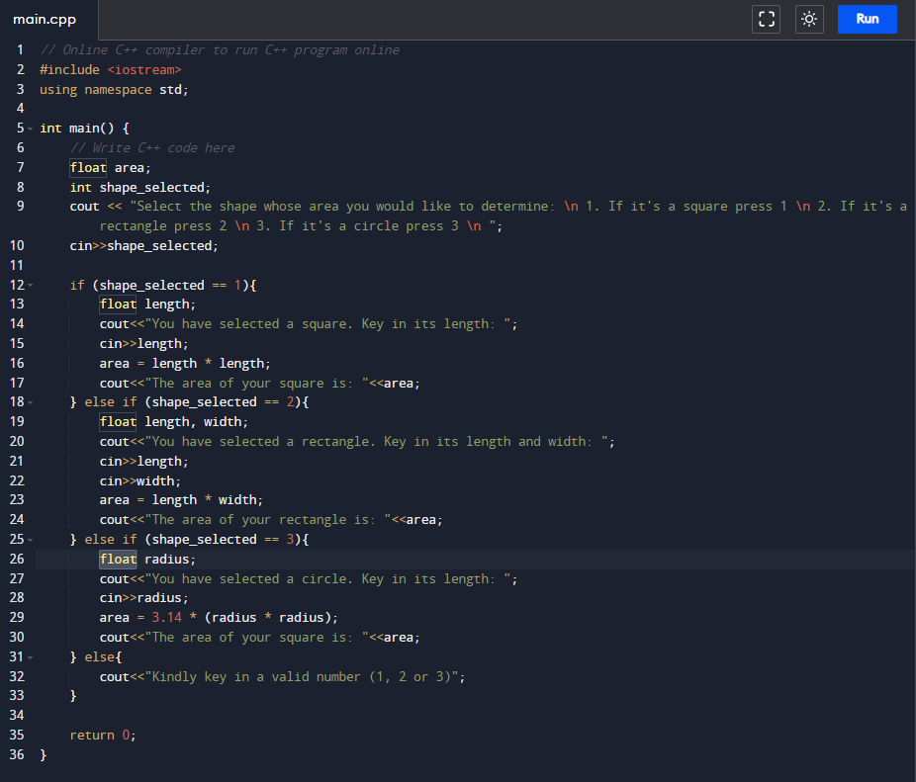

**Result:**

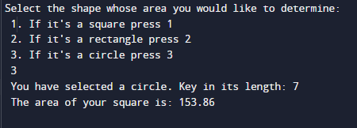

1. **Implementation using Java:**

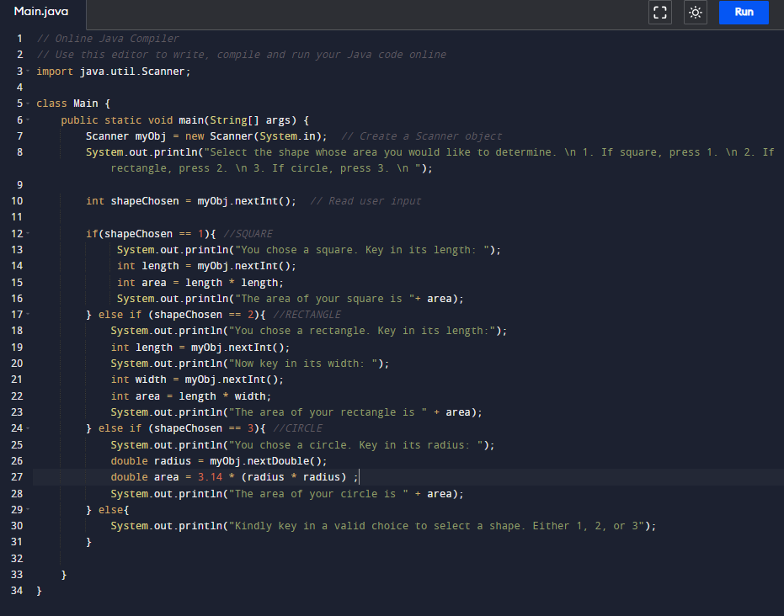

**Result:**

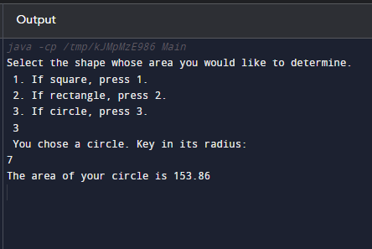

**B. IMPLEMENTATIONS USING SWITCH-CASE:**

1. **Implementation Using Python:**

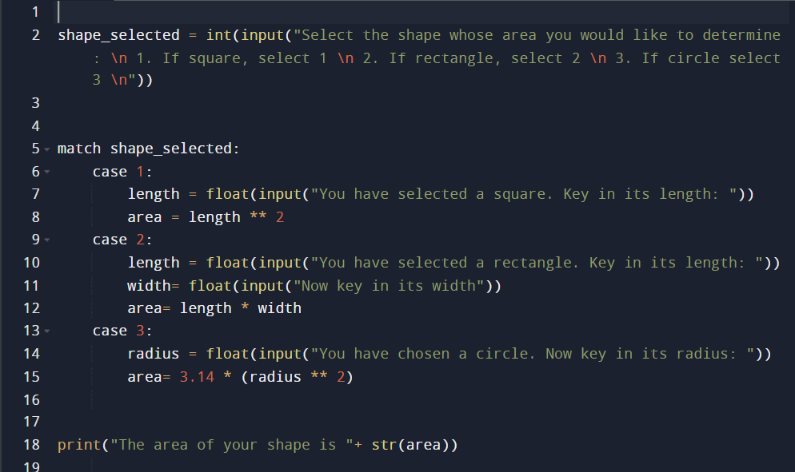

**Result:**

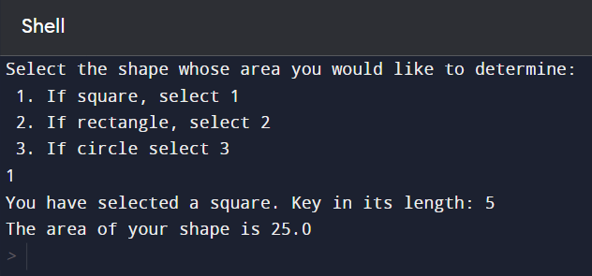

**2.Implementation Using C++**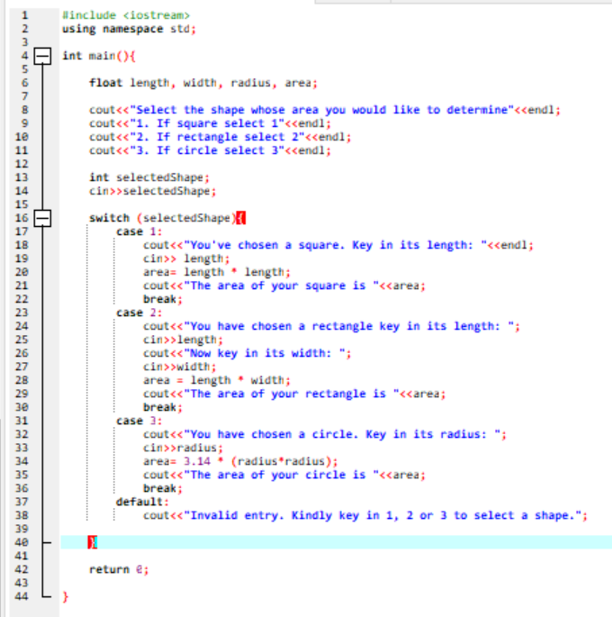

**Result**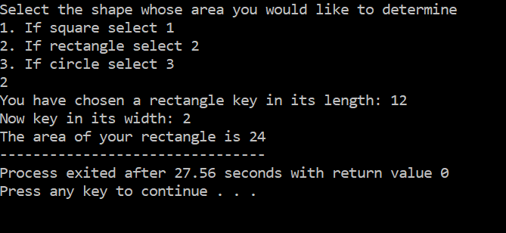

**3. Implementation Using Java**

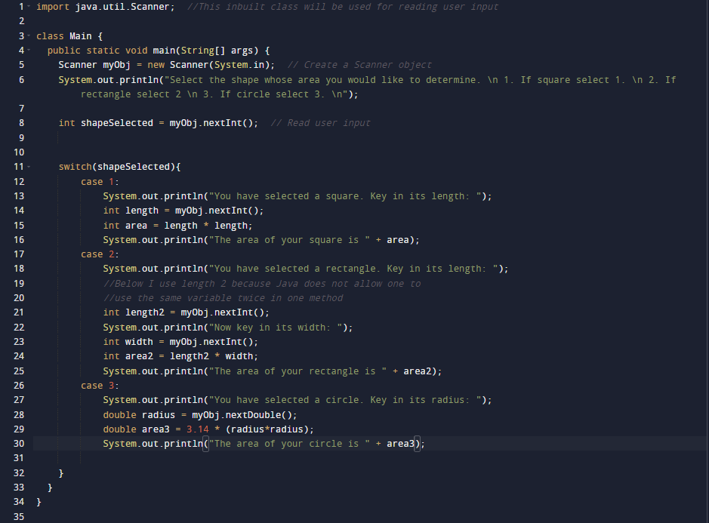

**Result:**

